AP Calc AB Name: _______________

______________ _____________

WS Assessment

Target 17:

Integrating using substitution

**I can:**

* Calculate an integral using substitution

Unit 6: Integration and Accumulation of Change

HW Target 17 Unit 6 Progress Check FRQ A and B

You check some basic integrating in cheat sheet

Substitution method $\int{f\left(g\left(x\right)\right)g^{'}\left(x\right)dx=\int{f\left(u\right)du}}$

$\int{{(x^{3}+2)}^{2}3x^{2}dx}$ $\int{{(x^{3}+2)}^{1/2}x^{2}dx}$

$\int{\frac{8x^{2}}{{(x^{3}+2)}^{3}}dx}$ $\int{\frac{x^{2}}{\sqrt[4]{x^{3}+2}}dx}$

$\int{3x\sqrt{1-2x^{2}}dx}$ $\int{x\sqrt[3]{1-2x^{2}}dx}$

$\int{cos\left(x\right)}\sin^{2}\left(x\right)dx$ $\int{\cos^{4}\left(x\right)}sin\left(x\right)dx$

Find an equation of the curve passing through the point (3, 2) and having slope 5x2 – x + 1 at every point (x, y).

Let f be a function such that f '' (x) = 6x + 12.

a. Find f(x) if the graph of f is tangent to the line 4x – y = 5 at the point (0, -5)

b. Find the average value of f(x) on the closed interval [-1, 1]

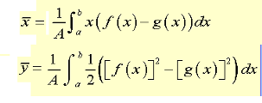

Find the center of gravity of the shaded area

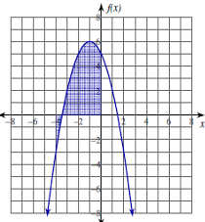

For each problem, find $\frac{d}{dx}F(x)$ in two ways

F(x) = $\int_{4}^{x}{\left(t-1\right)dt}$ F(x) = $\int_{-3}^{x}{\left(t^{2}+2t-3\right)dt}$

F(x) = $\int_{1}^{x^{2}}{\left(2-2t\right)dt}$ F(x) = $\int_{x}^{x^{2}}{\left(2-2t^{2}\right)dt}$

Evaluate the following 

The graph of f (composed of a semicircle and line segments) is shown below. If $g\left(x\right)=\int_{1}^{x}{f\left(t\right)dt}$, answer the following questions

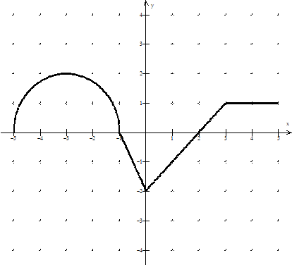

Find g(1) ; g’(1); g’’(1)

Is *g* increasing or decreasing at x = 1? Justify your answer.

Is *g* concave up or concave down at x = 2. Justify your answer.

State all x-values where *g* has a local/relative minimum. Justify your answer.

State all x-values where *g* has a point of inflection. Justify your answer.

Find g(2) and g(3)

Find the exact value of g(-3). (i.e. write you answer in terms of)

Graph *g* on the interval [-5,5]. Clearly indicate any points of inflection

and local extrema. (On the same graph above)

If the lower limit of the given function is changed to 2 (let’s say h(x) = $\int_{2}^{x}{f\left(t\right)dt}$)

how would the graph of this new function, *h*, look compared to the original

function, *g*? Explain

**Assessment Target 17**

Do any 5 of 1-digit problems 5 of 2-digit problems

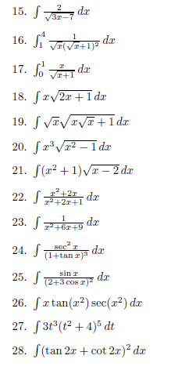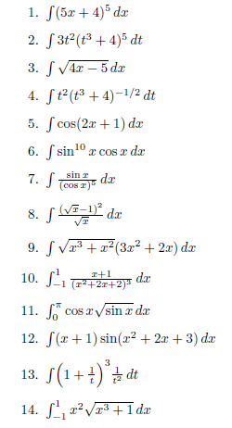

In the design of freeway exit ramps it is important to allow enough room for cars to slow down before they enter the frontage road. Suppose that the velocity is given by v(t) = 100 – 20(t + 1) ½ where v(t) is in feet per second and t is the number of second since you start to slowing down. Find the distance of the ramp in feet if the car is allow to spend maximum 8 seconds on the ramp.

Find an equation of the curve passing through the point (2, 3) and having slope 5x2 – 2x + 3 at every point (x, y).